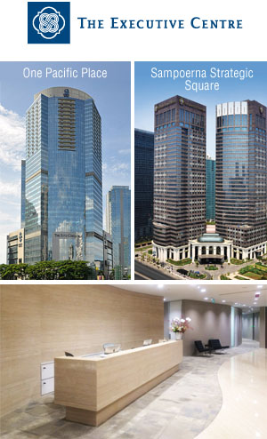 | City Head - Jakarta  Mr. Ferri Pranata  T +6221 2985 9888  M +6285 5150 0021  F +6221 2985 9889  E ferri_pranata @executivecentre.com  W www.executivecentre.com  The Executive Centre  Founded in 1994, The Executive Centre is Asia's leading premium serviced office provider, with over 70 centres across 21 major cities around the Asia-Pacific regions.  At the cutting edge of the serviced office industry, The Executive Centre provides the highest quality of on-demand serviced offices, virtual offices, meeting facilities, video conferencing and a broad range of business concierge services in the most prestigious Grade A office buildings in the central business districts of every city in which it operates, with a dedication to serving the business interests of multinational corporations, small and medium enterprises, and start-ups locally, regionally and internationally with the most flexible and dynamic workplace solutions.  The Executive Centre Indonesia - Addresses in Jakarta:  Level 11, One Pacific Place,  Sudirman Central Business District  Jl. Jend. Sudirman Kav. 52-53  Jakarta 12190, Indonesia  Level 18 & 30, Sampoerna Strategic Square  South Tower, Jl. Jend Sudirman Kav 45-46  Jakarta 12930, Indonesia

